H.T No
Regulations:
A15


Sreenidhi Institute of Science and Technology
(An Autonomous Institution)
Code No: 5A242 Date: 03-Feb-2020 (FN)

B.Tech I-Year II-Semester External Examination, Jan/Feb-2020 (Supplementary)
NETWORK ANALYSIS (ECE and ECM)

Time: 3 Hours Max.Marks:75

Note: a) No additional answer sheets will be provided.
b) All sub-parts of a question must be answered at one place only, otherwise it will not be valued.
c) Missing data can be assumed suitably.

Part - A Max.Marks:25

Answer all QUESTIONS.

1. | Compare series and parallel circuits. | [3M]
2. | Define average value of an alternating quantity. | [3M]
3. | Define crest factor. | [3M]
4. | Find the value of R_{L} for maximum power transfer.  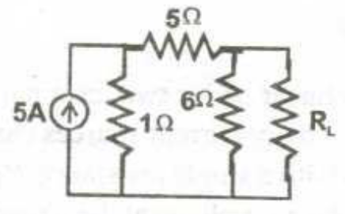 | [3M]
5. | Define bandwidth. | [3M]
6. | State the dot rule for coupled circuits. | [2M]
7. | How the RL circuit behaves for the step input? | [2M]
8. | What is the voltage triangle for a RLC series circuit? | [2M]
9. | What is the tuned circuit? | [2M]
10. | Write short notes on Low pass filter. | [2M]
Part – B Max.Marks:50
ANSWER ANY FIVE QUESTIONS. EACH QUESTION CARRIES 10 MARKS.

11. | a) | State and explain Ohm’s law with an example. | [5M]
 | b) | Obtained the equivalent resistance R_{ab} in the circuit and use it to find current i?  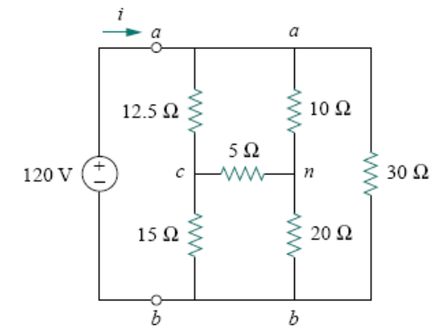 | [5M]
12. | a) | Explain source transformation Technique? | [5M]
 | b) | Use mesh analysis to find the current i_{o} in the below circuit?  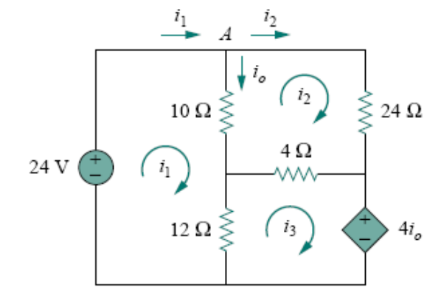 | [5M]
13. |  | For the network shown in fig determine the number of all possible trees. For a tree consisting of (1, 2, 3) (i) draw the tie set matrix (ii) draw cut set matrix?  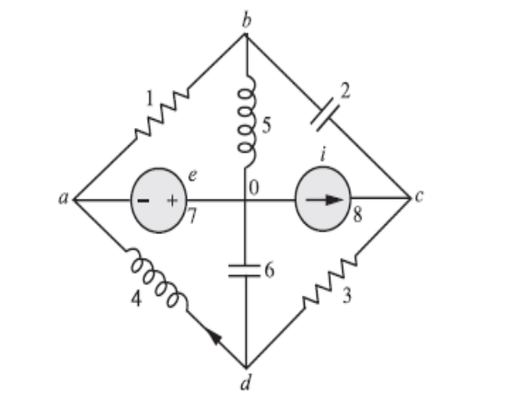 | [10M]
14. | a) | Determine the power generated by each source and the average power absorbed by each passive element in the circuit?  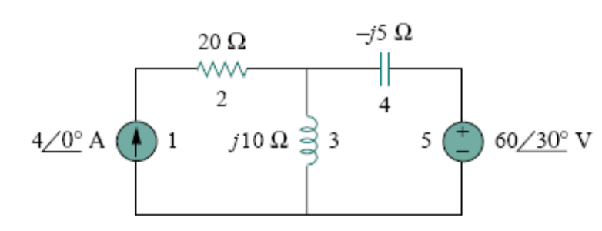 | [5M]
 | b) | When a resistor and a choke coil in series are connected to a 240V supply, a current of 3A flows, lagging 37⁰ behind the supply voltage. The voltage across the coil is 171 volts. Find the resistance and reactance of the coil, and the resistance of the resistor?  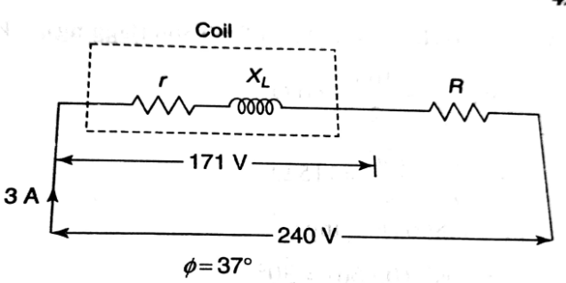 | [5M]
15. | a) | For the circuit shown in below fig find "i" using the superposition theorem.  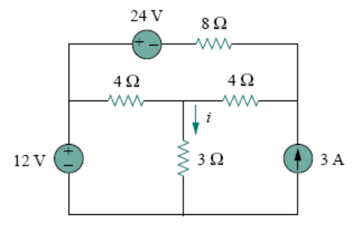 | [5M]
 | b) | Determine the value of R_{L} that will draw the maximum power from the rest of the circuit? Calculate the maximum power?  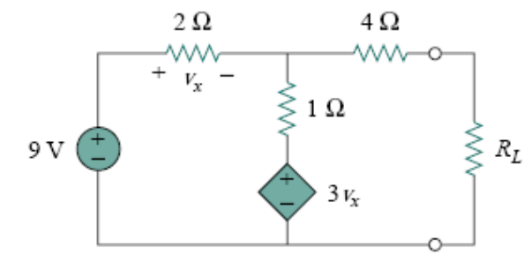 | [5M]
16. | a) | Find the inverse transmission parameters for the network shown in below fig?  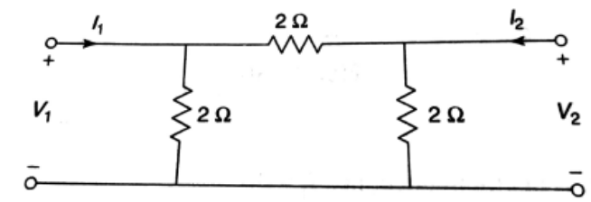 | [5M]
 | b) | The Z parameters of a two port network are Z₁₁ = 20Ω Z₂₂ = 30Ω Z₁₂ = Z₂₁ = 10 Ω. Find Y and ABCD parameters? | [5M]
17. | a) | Design a T-section constant K high pass filter having a cut off frequency of 10KHz and a design impedance of 600Ω. Find its characteristic impedance and phase constants at 25KHz? | [5M]
 | b) | Design a constant-K band stop filter having cut-off frequencies at 2000Hz and 5000Hz and characteristic resistance of 600Ω? | [5M]
18. | a) | In the below network the switch is closed. Assuming all initial conditions as zero, find i, and at t = 0⁺?  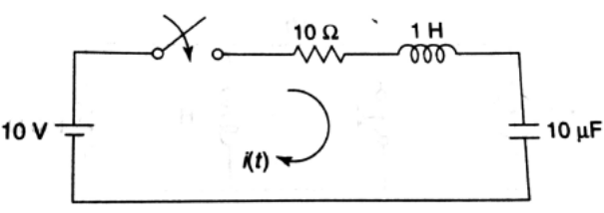 | [5M]
 | b) | In the below network, the switch is opened at t = 0. Solve for v, and at t = 0⁺?  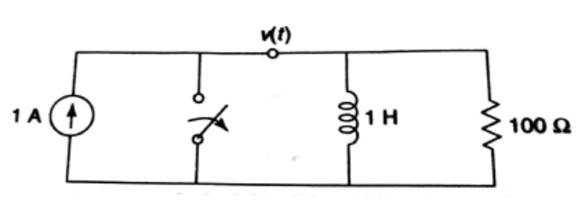 | [5M]

-- 00 -- 00 –

